Understanding Your Role in Reducing Stormwater Runoff Pollution
WHEN MAINTAINING WATER FEATURES

Water feature maintenance activities at your home or neighborhood pool can affect water quality. Wastes generated from spas, fountains and swimming pools during routine maintenance activities, end-of-year shut down, acid washing, and plaster or grouting operations, are pollutants that can degrade our water quality.

The wastewater that drains from inside your house is treated and cleaned before it enters a drainageway through the sanitary sewer system, but any flows from your backyard and outside your home go directly to the nearest drainageway, without any treatment. So it is very important that nothing is discharged into your backyard, onto street surfaces, or into the storm drains that can make it to the drainageway without pre-treatment.

Your neighborhood recreation center may have a sanitary sewer connection, with a permit for direct discharge that has its own set of requirements to follow. In that case, you will see no discharge from the pool area. If you do see discharge, please contact the appropriate contact on the back.

Improper disposal of wastes from water features is harmful to the environment and may violate state and federal laws.

The information on this brochure is designed to assist you in properly maintaining your water features, recognizing potential improper discharges, and reporting these observations.

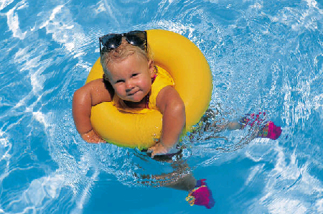

- Never discharge pool, spa or fountain water that has not been properly de-chlorinated.

- Never discharge pool, spa or fountain water that contains harmful amounts of copper.

- Never discharge filter backwash into the storm drains, storm sewer inlets, or directly to the drainageway.

- Never discharge wastes from acid washings to the storm drain, storm sewer inlets, or directly to the drainageway. AND don’t discharge this waste to the sanitary sewer system without first neutralizing it. Contact your local sanitary district prior to any non-typical discharge activity.

- Never discharge waste or wastewater from plastering or grouting maintenance activities to either the storm drain or sanitary sewer. These wastes need to be contained and disposed properly.

- Never open a manhole to discharge pool water.

DON’T

DO follow these guidelines:

- Pre-treat your pool, spa, or fountain water by de-chlorinating it prior to discharging it to the storm drain system. This can be accomplished by adding a de-chlorinator available at a pool supply store, or letting the chlorine level decrease on its own. Test the chlorine level to verify appropriate de-chlorinating pretreatment.

- Discharge your pool water to the storm drain only if you know that it does not contain harmful concentrations of chlorine.

- Maintain the proper chemical balance and filtration in your water feature. This will minimize the need to drain the feature and limit the amount of corrosion of pipes and equipment.

- Use copper algaecides only when necessary; if you use these cooper products, you must verify the water does not contain harmful amounts of copper prior to discharge to the storm drain.

- Dispose of wastewater from washing cartridge filters in a grassy area to maximize infiltration.

- Dispose of spent diatomaceous earth filter medium in your trash.

- Make sure your pool maintenance service contractor follows all discharge requirements.

- Dispose of unwanted pool chemicals properly; some of them may be hazardous and require special care when discarded. Contact Curbside, Inc. at 800-449-7587 for more information on this service.

