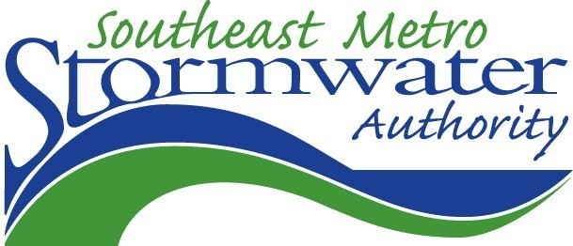

City employees, or City-contracted personnel who perform maintenance on City vehicles and equipment.

DO NOT leave a leaking vehicle unattended; use a drip pan temporarily and then drain fluids if not being repaired and waiting for final deposition.

DO NOT place a waste in an area not designated for its hazardous nature or if that areas’ disposal method is not a recommended one.

DO NOT wash or hose down the garage area except where the wash water will only enter the sanitary sewer drain as an approved discharge; use dry clean- up methods as often as possible.

DO NOT repair equipment or vehicles outside; use a covered, designated area for such repairs.

General Vehicle Maintenance Activities

Drain fluids from leaking or wrecked vehicles, and from motor parts, as soon as possible, and dispose of fluids properly.

Park vehicles to be maintained in the designated areas (drip pans available); Monitor parked vehicles closely for leaks; use drip pan as needed.

Conduct maintenance and repair activities indoors whenever possible to minimize exposure of fluids to stormwater runoff.

Keep maintenance equipment clean; do not allow a build up of oil/grease.

Keep all work areas neat & well organized; Sweep/ pick up all trash & debris daily or as needed. Label containers, sign procedures, and designate areas.

Conduct daily inspections to ensure that equipment & materials are being handled, disposed and stored correctly; Recycle or dispose of all wastes properly and promptly.

Have spill cleanup materials nearby; Clean up spills promptly, with DRY methods; do not hose down; cleanup is completed ONLY after absorbent disposed properly and rags disposed or sent to industrial laundry.

DO NOT transfer, pour or dispose of maintenance fluids outdoors near or in storm drains, or ditches.

DO NOT let waste accumulate at or around the work place; more clutter equals more accident opportunities.

**DON’T**

**DO**

***HOW?***

The County’s Road & Bridge Peoria Street facility, specifically the maintenance bays and corresponding storage areas.

This **Vehicle Maintenance** SOP provides operational best management practices (BMPs) developed to control pollutant discharges by promoting regular maintenance of City-contracted vehicles and equipment, as well as appropriate activities within the maintenance shop and bays. Several operational components of vehicle maintenance activities have the potential for polluting receiving waters, including storage while waiting for repair (leaks); parts cleaning (spills), storage of maintenance fluids used in repairs and routine maintenance (leaks & spills); and the maintenance facility itself (poor good housekeeping practices). These procedures are critical steps that must be included during all maintenance activities, pre-repair storage and post-storage of vehicles to be maintained.

***What***



Who

***Where***

***Why***

**Standard Operating Procedures (SOPs)** have been prepared for all activities conducted as part of the City’s Municipal Operations functions that have the potential to impact ‘waters of the state. One of the primary goals of these SOPs is to **provide time-tested, generally accepted routine procedures that minimize the potential for release of pollutants from the site during the performance of municipal operations activities.**

This Fact Sheet provides an overview of the SOP document, and the role of staff in implementation of the required controls.

## Vehicle Maintenance SOP

**Your Actions Prevent Stormwater Pollution!**

# **Standard Operating Procedures for Water Quality Protection**